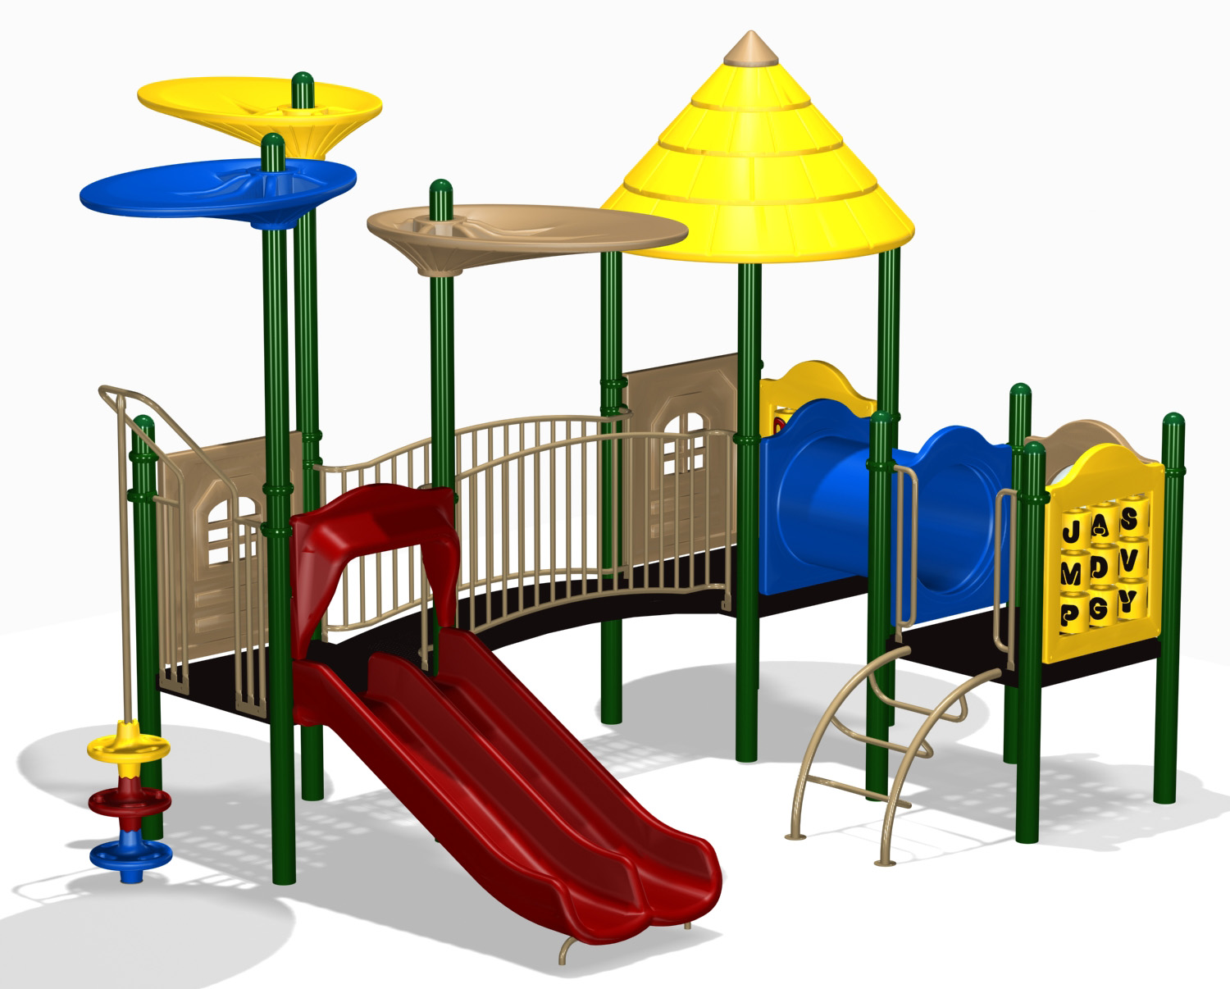
Night of Gratitude Playground Fundraiser

Easton Park & Recreation and The Mom’s for a Better Playground are teaming up to bring “A Night of Gratitude”, a fundraiser to recognize the unsung volunteers who help make Easton not just a town but a community that we are proud of! We are asking YOU to nominate anyone you think should be recognized for their outstanding volunteering and hard work in the town of Easton.
Can’t think of anyone to nominate? No problem! Feel free to buy a ticket and come on down to support the Playground Fundraiser!
-OR- feel free to just give a donation to the Playground Fund!
Donations can be dropped off at Easton Park & Rec in person or mailed to 652 Morehouse Rd, Easton CT 06612.

Come join us on May 26th at Brennan’s Shebeen in Fairfield to celebrate our volunteers! All proceeds raised will go towards the Easton Park & Rec Playground Fund, to replace the playground equipment located next to the tennis courts on Sport Hill Road.
Thursday, May 26th, 6:00 – 9:00 pm
Ticket Info: $40/for adults & $20/kids; includes appetizer buffet, soda, water, coffee & dessert ($cash bar$)
There will be a raffle with some great prizes!
Location: Brennan’s Shebeen 2425 Morehouse Hwy, Fairfield CT

Tickets can be purchased through our website at www.eastonrec.com and at the Easton Park & Rec office through May 13th
Please contact the Easton Park & Recreation office with any
questions (203) 268-7200.

